
5-C Model of Communication
How SLPs Can Foster Collaboration and Strengthen Communication with Stakeholders
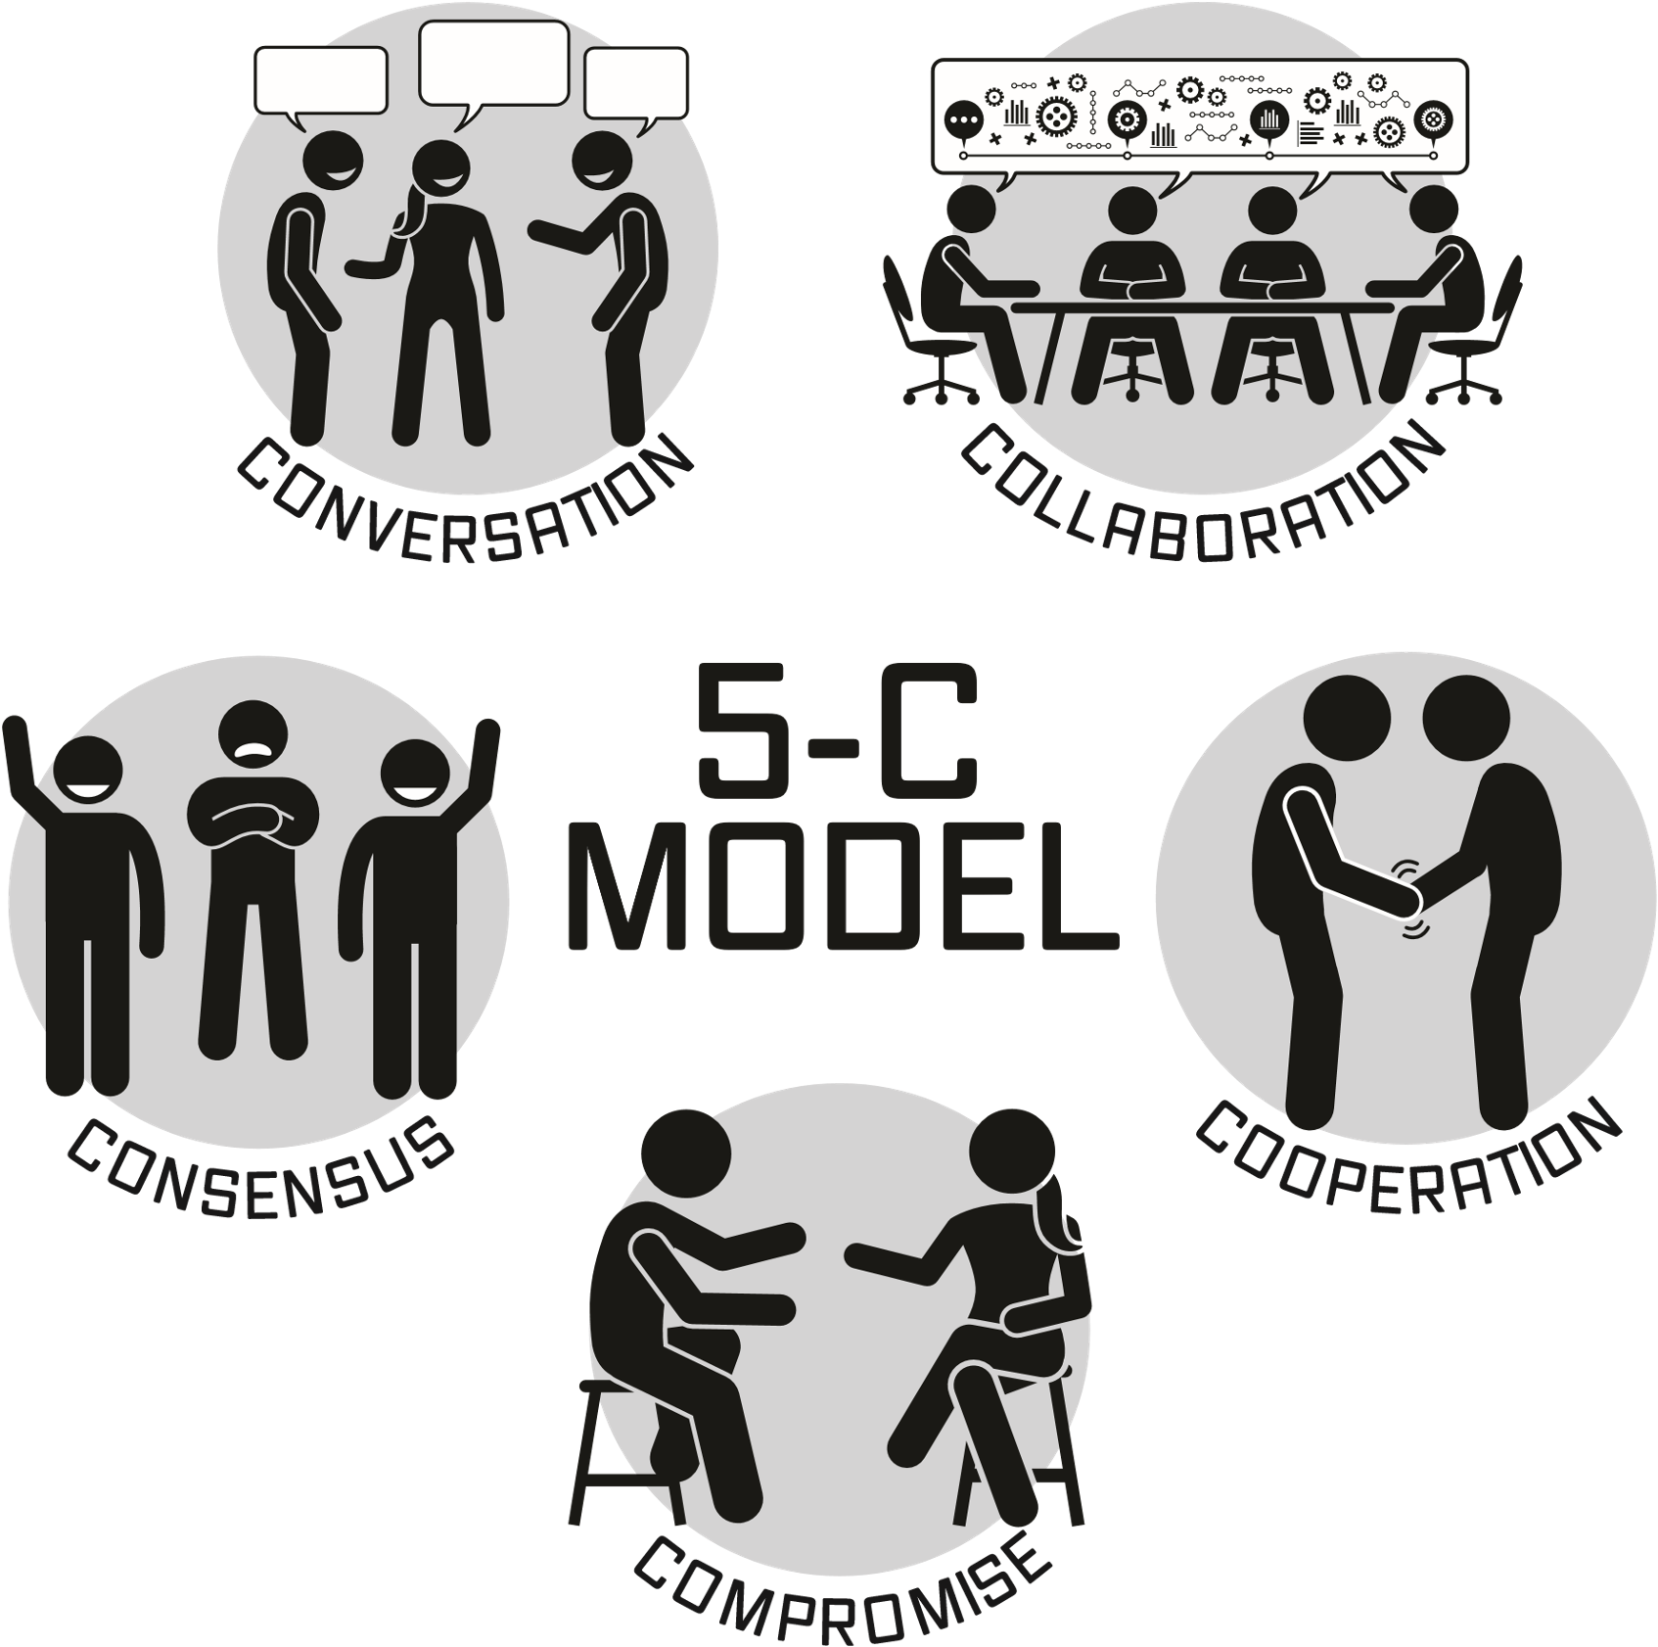

The biggest problem with communication is the illusion it has taken place.
Learning Outcomes

BUILD an understanding of the core components of the 5-C Model of Communication.
LEARN how to use this framework when interacting with parents and colleagues.
EXAMINE the role effective communication plays in the team process
Effective Communication builds trust, encourages conversations, and is the path to consensus

CONVERSATIONS
- Questions____________________________________________________
- Dialogues ____________________________________________________
- Active Listening _______________________________________________
https://www.ablenetinc.com/why-active-listening-makes-all-the-difference-for-speech-language-pathologists-on-demand-registration/
- Perspective Taking _____________________________________________
COLLABORATION
  - Shared vision__________________________________________________
______________________________________________________________________
______________________________________________________________________
COOPERATION
____________________________________________________________________________________________________________________________________________
______________________________________________________________________
COMPROMISE
____________________________________________________________________________________________________________________________________________
______________________________________________________________________
CONSENSUS
____________________________________________________________________________________________________________________________________________
______________________________________________________________________
Take Aways to foster collaboration and strengthen communication.
1.____________________________________________________________________
2. ___________________________________________________________________
3. ____________________________________________________________________
Peggy S. Bud
Author, TEDx Speaker, Communication Consultant, Speech/Language Pathologist
Peggy@PeggyBud.com
www.PeggyBud.com
www.NavigatingSpecialEducation.com

